# [Hydroponic Growing](https://www.johnnyseeds.com/growers-library/hydroponics-information-guide.html)

## Hydroponic Conclusions

Overall very customizable

Prolonged Shelf Life

[Sizing a Hydroponic System](https://growerssupply.wordpress.com/2016/05/31/sizing-a-hydroponic-system/)

Tank Size:

1. small plants require at least ½ gallon per plant,
2. medium plants 1 ½ gallon
3. large plants 2 ½ gallons

Difficult to over water the plants as their roots float in the water all the time; taking just the water and nutrients they need.

Usually divided into two forms

1. Open System-nutrient solution and supporting media in open systems are not reused or recycled
   1. Less susceptible to salinity/infection
2. Closed System-nutrient solution and supporting media in open systems are reused/recycled
   1. More cost effective

Recommend Liquid systems( Soil systems for effective for fruity plants)

Liquid seems best for growing microgreens, should still do a trade study to determine best. Other factors to worry about (cost, how complicated a system, etc.

|  |  |  |
| --- | --- | --- |
|  | Pros | Cons |
| Nutrient Film Technique | * Water flow determined by slope of tray/power of pump * Constantly under nutrient rich conditions * Constant observation of water not required | * Roots are susceptible to fungal infection because they are constantly immersed in water or nutrient solution * Need some kind of draining system |
| Deep Water Culture | * Constantly under nutrient rich conditions * Simple | * Algae and molds can grow rapidly in the reservoir * Need to closely monitor nutrient/ oxygen etc conditions * Not good for large crops |
| Aeroponic | * Even and delicate control * Sprayer give highly oxygenated nutrients | * Misting cycles must be optimized due to roots being exposed to air and drying * Expensive to install and maintain * Partial failure easily kill plants |
| Wick | * Useful for small, indoor cultivation * Self-feeding (no water pump) * Wick inhibits disease * Simple | Not good for large plants |
| Drip | * Customizable per plant | * Draining system needed |
| Ebb and Flow | * Can customize growing media | * Requires observation to control water provided * Disease/algae can grow easily |

Differences

Plants receive fertility from nutrient solution rather than soil

[Link to basic rundown of hydroponic types](https://www.nosoilsolutions.com/6-different-types-hydroponic-systems/)

One big difference between liquid and substrate hydroponic systems is that

substrate systems usually require one emitter per plant, to deliver the nutrient

solution to the roots. This is in contrast to liquid hydroponics, where the nutrient

solution is contained in the root zone by the channel or the basin, depending on

the system.

Soilless crops are fertilized every day, at every watering

Slab/Bucket culture -fruiting crops(tomatoes,cucumbers, peppers,etc)

Liquid Systems - leafy crops (lettuce,greens,herbs)

NFT systems- microgreens and shoots

## Insert Design Matrix from Sheets Here

## No Solid Medium/Substrate Systems

Hydroponic systems where the roots bathe directly in nutrient solution, without

any type of solid soil substitute securing the plants, are known as liquid hydro

systems. Soils can also be used in these cases. There are three main types:

Nutrient Film Technique (NFT). NFT systems use long gutters or troughs to

hold the plants as they grow. Typically, there is a cover on the gutter, with holes

where the plants are placed. The roots grow in the gutters without any medium

other than a small plug securing the plant in place. Nutrient solution is piped in

at the top of the gutter, flows down, and drains at the bottom of the channel.

The nutrient film refers to the thin layer of nutrient solution present in the

channel where the roots grow.

Best for plants that have a small root system

* Pros:
* Does not require constant observation to control water provided to system
* The solution is collected and reused, and the amount of water is controlled by the slope of the tray and the power of the water pump
* Constantly under nutrient-rich conditions

Cons

* Roots are susceptible to fungal infection because they are constantly immersed in water or nutrient solution

[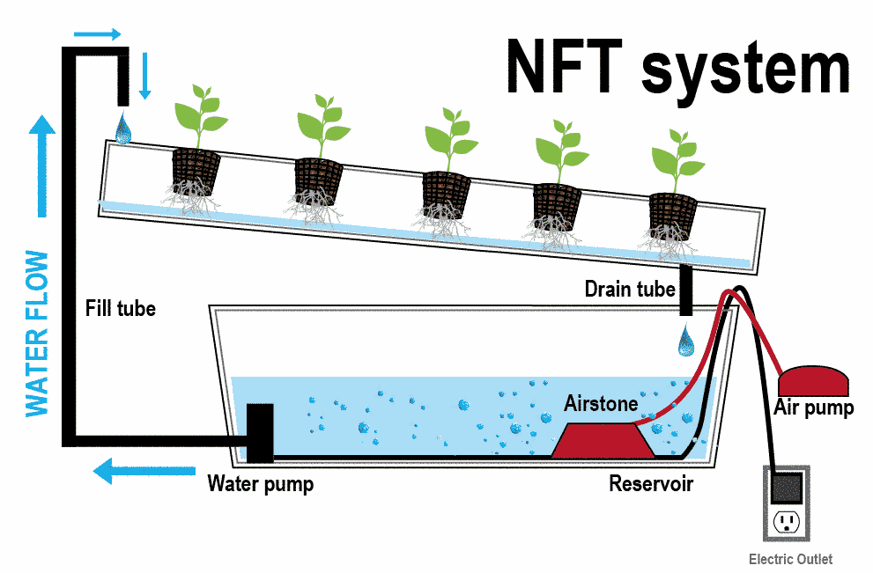](http://hydroponicsfarm.weebly.com/nutrient-film-technique-nft.html)

Deep Water Culture (DWC). Another common method of hydroponic

production that does not involve a solid growing medium, deep water culture

involves growing crops in standing nutrient solution, with the roots dangling in

the solution. Instead of channels, crops grow in tubs or basins, with the plants

commonly anchored in floating rafts, with no medium other than the plugs

securing the plants in place.

Pros

* With improvement of aeration methods to keep dissolved oxygen, the deep water culture system was developed so that plants can be grown with roots constantly suspended in water
* Produces food actively: a floating platform supports plants or pots in a reservoir, where the root parts are constantly immersed in the water or nutrient solution and oxygen is supplied by an air pump and air stone

Cons

* necessary to monitor the oxygen and nutrient concentrations, salinity, and pH
* Large/Long term crop not grow as well(though still can)
* algae and molds can grow rapidly in the reservoir

[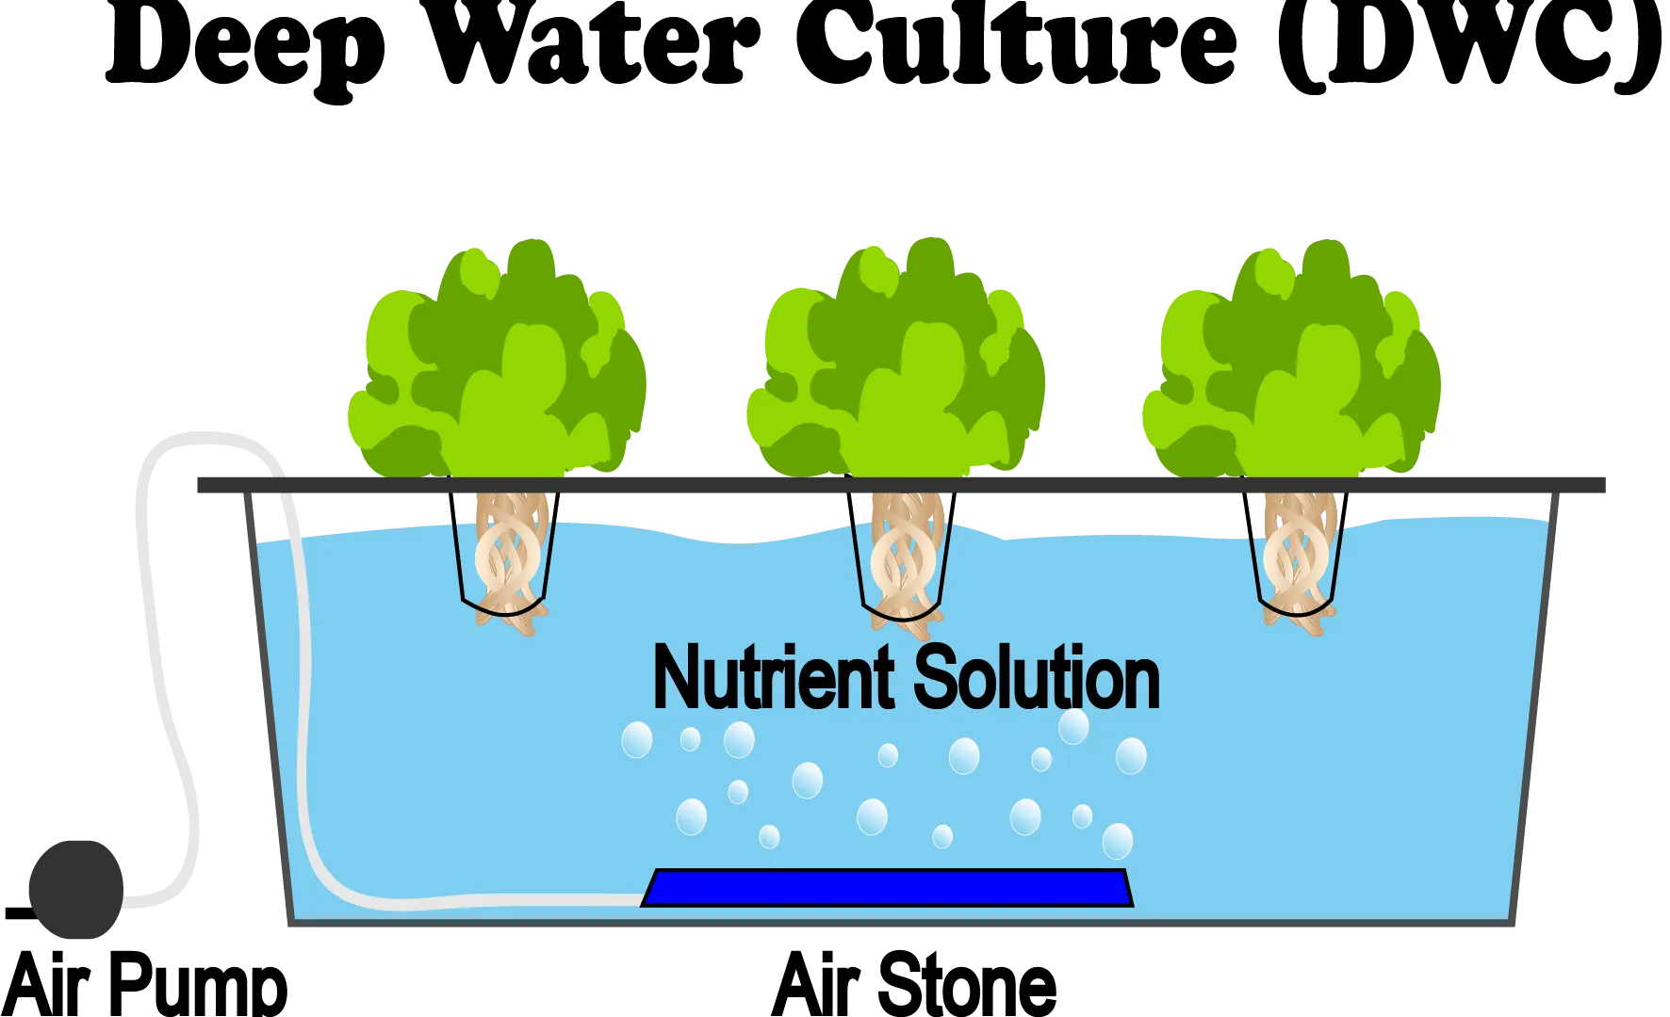](https://www.nosoilsolutions.com/deep-water-culture-hydroponics/)

Aeroponics. Aeroponics is a third way crops can be grown without a medium.

In aeroponics, the plugs holding the seedlings are suspended in systems where

the roots dangle and are sprayed at regular intervals with nutrient solution,

instead of being irrigated with liquid. Currently aeroponics is less common than

NFT or DWC.

Pros

* Even and delicate control over root system w/ no required media
* Easy to add highly oxygenated nutrients to plant through sprayer

Cons

* Customizing the misting cycles to particular plants is important, because their roots are exposed to the air and can dry rapidly.
  + Mist easily affected by outside temperatures
* Expensive installation and maintenance
* Frequent cleaning to prevent plant disease and clogging of spray heads.
* Partial failure of system can easily damage or kill plants

[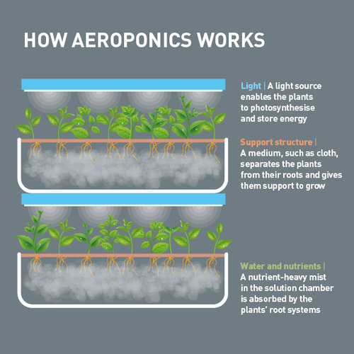](https://www.lettusgrow.com/blog/aeroponics-explanation)

Wick System

Water or a nutrient solution in a reservoir is supplied through a wick or fibrous materials (typically nylon) that can absorb and transport water from the reservoir to the root area by capillary action

Pros

* Excellent model for cultivating indoor plants(useful for small scale)
* self-feeding model and does not require a water pump
* Wick inhibits the diseases common to overwatering

Cons

* Not suitable for large or long term plants, which need a larger amount of water than the wick can supply

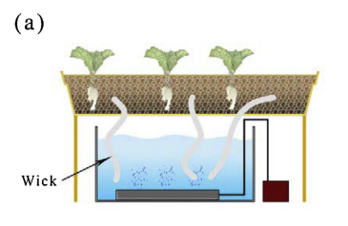

Drip System

Water or a nutrient solution in the reservoir is delivered to each plant or pot using a pump with the amount of water for each plant adjusted by an electronic timer.

The drip system is divided into two models, recovery and non-recovery, depending on the processing of the reused water or nutrient solution.

In the recovery system, the water or nutrient solution is collected and returned to the reservoir and then recirculated through the system. This makes it more economical than the non-recovery model, but reusing the solutions may result in pH changes and growth of algae or mold in the reservoir or tubing system.

In the non-recovery drip system, amount of water or nutrient solution needs to frequently be monitored in the reservoir to ensure that enough water or nutrient solution reaches the roots of the plants

Pros

* Customizable per plant

Cons

* The system is also vulnerable to power outage causing stress or death to plants.

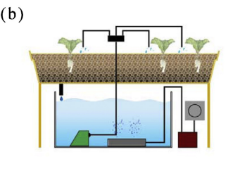

Ebb and Flow System

Uses an automatic flood and drain watering technique, in which plants are flooded temporarily and periodically. The water or nutrient solution in the reservoir ascends to a growth tray via a water pump, accumulates to a certain level, and stays in the growth tray for a set amount oftime, providing water and nutrients to the plants. After a predetermined time, the solution is drained back into the reservoir through a tubing system

Pros

* Can add various types of media around roots

Cons

* Circulation system requires continual observation to control the amount of water provided to the system.
* Root disease and growth of algae or molds may easily occur in this system
  + Include a filtration step or other method for sterilization of the water

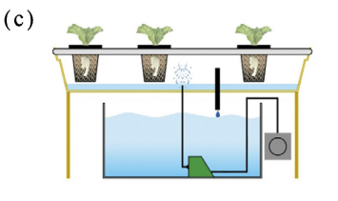

## SOLID MEDIUM/SUBSTRATE SYSTEMS

Hydro systems using a medium can be divided broadly into container culture and

slab culture. The medium holding the plant in hydro systems can be composed of

a wide range of inert materials, including rockwool, coir, sand, perlite, sawdust,

wood chips, or others.

Container Culture. Container culture refers to the use of containers to hold

the loose, soilless medium in which the plants grow. The containers can be

anything from buckets, pots, or grow-bags specifically manufactured to hold

plants, to repurposed bags, buckets, or other alternatives.

Slab Culture. In slab culture, plants are grown in long, flat slabs of media that

are made specifically for this purpose. The most commonly available materials for

slabs are rockwool and coco coir. Slab dimensions vary by crop and conditions,

but they are typically a couple of inches deep, a foot or so wide, and a few feet

long. Each slab is designed to house multiple plants growing from its top, with

the number of plants depending on the type of crop. Slabs are usually wrapped

in plastic or biodegradable film, to contain the nutrient solution. Individual slabs

are laid end-to-end to form a row.

[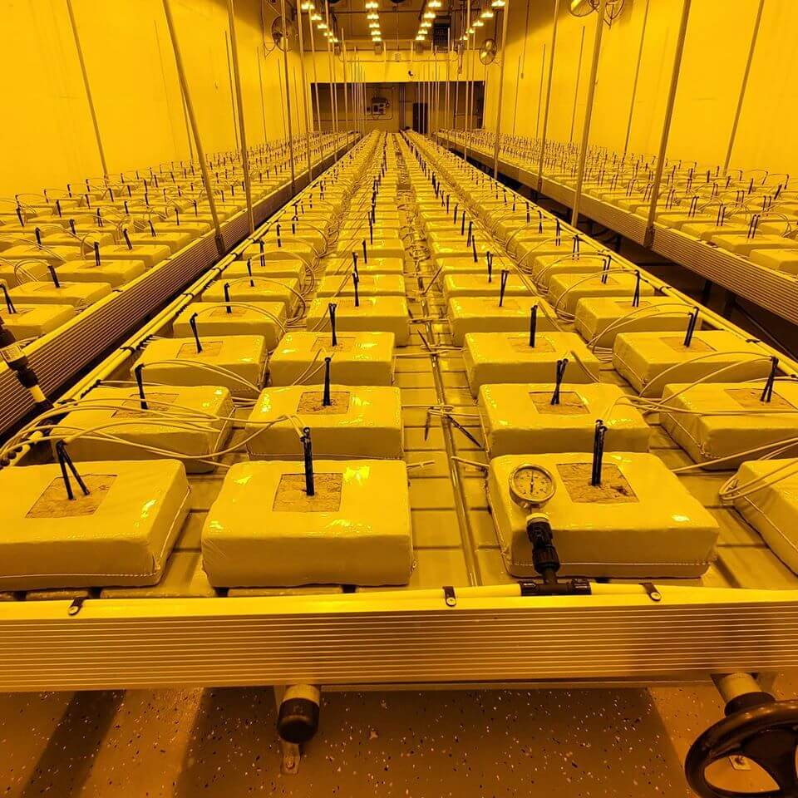](https://redrockblock.com/wp-content/uploads/2020/04/rockwool-flowering-slabs.jpg)

Aquaponics. This methodology involves growing crops with the recycled

nutrient waste from aquaculture. The nutrient solution is derived directly from

water used to raise fish or other aquatic animals. The nutrients in the waste from

the animals are used to feed the crops, creating an efficient food production

system. Aquaponic systems can be integrated with any of the above hydro

systems. The aquaculture waste is the source of fertility, and the hydro system of

choice, whether NFT, DWC, or otherwise, is the method of delivery.

[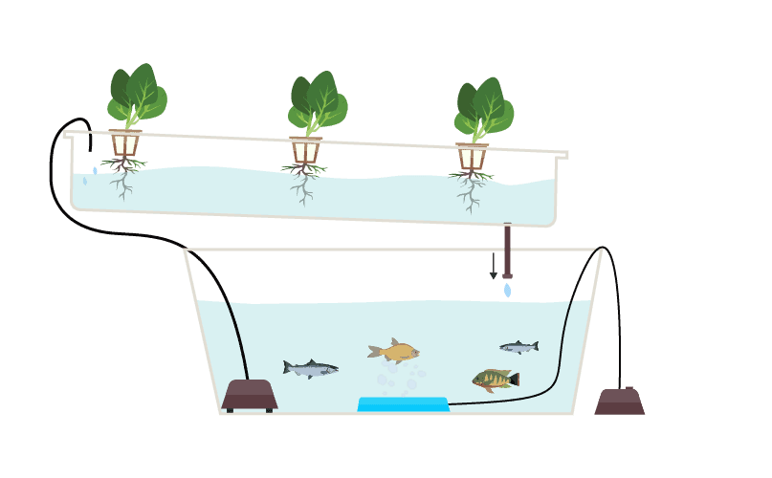](https://www.greenandvibrant.com/aquaponic-gardening)

## Hydroponic vs Traditional Soil

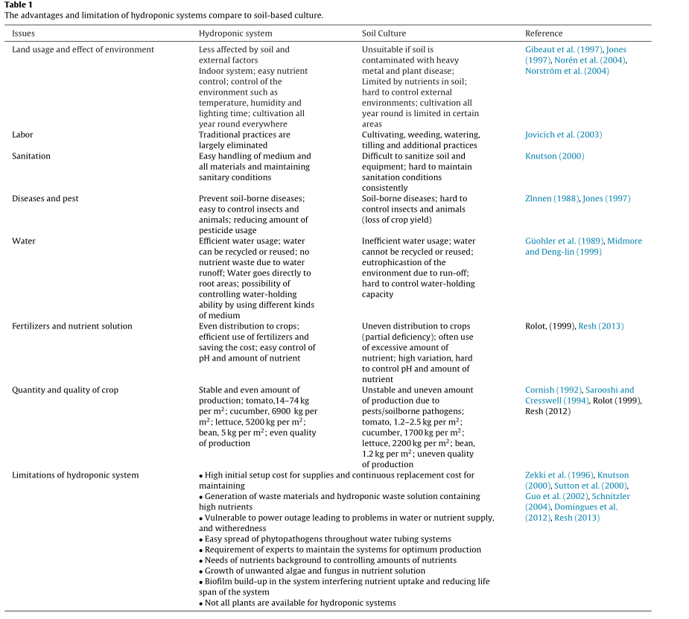

Tackling Limitations of Hydroponic methods

Fungal Infections-

* High dose of ultraviolet irradiation and gamma irradiation applied to inactivate growth of pathogens in the nutrient solutions and to prevent disease outbreaks in hydroponic systems.
* Chemical control strategies- suppress growth of plant diseases
* Use of certain bacteria to prevent disease growth
  + Also acts as plant growth promoting rhizobacteria (PGPR)

Pathogens through water tubes

* Some kind of filtration system
* Use open system to not be reused

# [Nutrient Disinfection Methods](https://hal.archives-ouvertes.fr/hal-00886118/document)

## Heat Treatment (Pasteurization)

* Heating and cooling can be done rapidly in large amounts
* Can be energy efficient
* Able to heat solution in about 2 seconds using heat exchanger
* **Recommended conditions - 95 degrees Celsius for thirty seconds**
* Can be accompanied by rapid sand filter to remove debris
* Heating the nutrient solutions to these temperatures causes a build-up of precipitate of carbonates on the heating coils and pipes, so acid is often added to the nutrient solutions in small amounts prior to heat treatment
* Easy to monitor with thermostat
* Not a significant increase in temperature due to mixing with cooler fresh solution

## Chemical Treatment

### Surfactants

* Fungicidal against certain fungi
* Able to control root pathogens
  + Agral, a non-ionic surfactant, disrupts the plasmalemma of fungal structures such as zoospores which lack a cell wall, and in culture, motile zoospores of Pythium and Phytophthora will lyse (cell breakdown through membrane) within one minute of exposure
  + No apparent phytotoxicity
* Surfactants will degrade over time in recirculating systems, perhaps because of microbial action, so they must be reapplied periodically.
* Since surfactants will cause foaming, the 326 D.L. Ehret et al. lack of foaming may be used as a guide to the timing of additions

### Elements

* A number of essential elements for plants have been found to be toxic to disease-causing microorganisms at high concentrations
* Potential of phytotoxicity at normal concentrations
* Used sparingly

### Oxidants

* Problem- the use of oxidants for disinfestation is the fact that they are highly reactive with organic solutes (very common in hydroponics)
* Oxidation reduces effectiveness of disinfection and can produce halogenated by-products
* Affect ecological balance
* Can cause phytotoxicity at root zone
* Very effective at disinfection

#### Ozone

* Very strong oxidizing agent
* Relatively unstable but decomposes completely and w/o a trace
  + Been used successfully for years as a disinfectant for drinking water, waste water and aquaria
  + Recently been developed for hydroponics
* Less effective in hydroponics

#### Hydrogen Peroxide

Not much

#### Chlorine

Can be used, not much research

### Ultra-Violet Radiation

* Wavelengths between 200 and 280 nm (UV-C) have a strong germicidal effect with an optimum at 253.7 nm
* UV sterilizer lamps very effective
* At high intensity, the ultraviolet sterilizer significantly inhibited the production of plants grown in the treated solution
  + Cause suspected to be due to ozone and/or free radicals in nutrient solution, which are known to be generated by UV radiation
* Interaction of UV light with Fe-chelates can be a problem in the disinfestation of nutrient solutions.
  + Under certain conditions, and depending on the Fe-chelate, plant growth may be significantly increased by the use of UV light for disinfestation of nutrient solutions
* High Pressure Lamps
  + UV-C radiation with a wavelength between 200 and 280 nm
  + Less energy efficient (10% compared to 40% of low pressure)
* Low Pressure Lamps - UV-C-rays predominantly at the optimum disinfestation wavelength of 253.7
* Recommended to use with rapid sand filters
  + Organic material affect UV transmission
* **Recommended conditions- 100 mJ⋅cm–2 for elimination of pathogenic fungi, and 250 mJ⋅cm–2 for complete disinfestation, including viruses**.
  + Large Built-in factor or safety

### Filtration

Need very small filter sizes

#### Membrane Filtration

* Micro, ultra, nanafiltration plus reverse osmosis
* Over time the concentration of particles remaining in the raw water increases and therefore this concentrate (reject water), has to be wasted from time to time.
  + Suggested that the rejected water be returned to the drain water catchment tank thus avoiding the loss of water and nutrients (20–30%).
* Clogging and leaking problems

#### Slow Filtration (Bio- Filtration)

* Widely adopted for closed cultivation systems in the horticulture industry
* Low energy input, low cost
* Passive disinfection (help nutrients)
* Raw water percolates very slowly (100 to 300 L⋅m–2⋅h–1) through a bed of fine filter sand or other filter material. Soon after the filter process begins, a “Schmutzdecke” (dirt layer or filter skin) forms on the surface of the filter bed. Its consistency varies widely depending on the organic and inorganic material of which it is composed. The “Schmutzdecke” shows a very high biological activity with its population of algae, protozoa, bacteria, fungi, actinomycetes, diatoms, rotifers etc.
* Despite long history and popularity, not very well understood
* Soon after the filter process begins, a “Schmutzdecke” (dirt layer or filter skin) forms on the surface of the filter bed. Its consistency varies widely depending on the organic and inorganic material of which it is composed. The “Schmutzdecke” shows a very high biological activity with its population of algae, protozoa, bacteria, fungi, actinomycetes, diatoms, rotifers etc.
* Scheme: The essential components of a slow filter are: – a filter box, – an inlet structure, – a bed of fine sand or other filter media (with supporting gravel layers if necessary), – an underdrainage system, – an outlet structure including a flow meter and control valves to regulate the velocity of water flow through the filter bed.

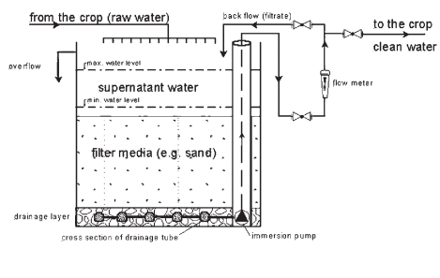

Effectiveness- Highly effective with 99% to 99.99% elimination rates

### Microbial Inoculation

Nah

### Breakdown

